A Mini Project - 1 Report on

Smart Waste Management System

Submitted to the Department of Computer Science & Engineering, GNITS in the partial fulfillment of the academic requirement for the award of B. Tech (CSE) under JNTUH

By

Amogha Sri Kommera 23251A0568 Sirimalla Vyshnavi 23251A0594 Sri Harshita Kemburu 23251A0595
under the guidance of
Dr. T. Rajesh Assistant professor



Department of Computer Science & Engineering
G. Narayanamma Institute of Technology & Science

(Autonomous) (For Women)
Shaikpet, Hyderabad 500 104.

Affiliated to
Jawaharlal Nehru Technological University Hyderabad
Hyderabad – 500 085
May, 2025

G. Narayanamma Institute of Technology & Science
(Autonomous) (For Women)

Shaikpet, Hyderabad – 500 104.
Department of Computer Science & Engineering



Certificate
This is to certify that the Mini Project - 1 report on “Smart Waste Management System” is a Bonafide work carried out by Amogha Sri Kommera 23251A0568, Sirimalla Vyshnavi 23251A0594, Sri Harshita Kemburu 23251A0595, in the partial fulfillment for the award of B. Tech degree in Computer Science & Engineering, G. Narayanamma Institute of Technology & Science, Shaikpet, Hyderabad, affiliated to Jawaharlal Nehru Technological University, Hyderabad under our guidance and supervision.

The results embodied in the project work have not been submitted to any other University or Institute for the award of any degree or diploma.

Internal Guide Head of the Department
Dr. T. Rajesh Dr. A. Sharada
Assistant Professor Professor & Head
Department of CSE

G. Narayanamma Institute of Technology & Science
(Autonomous) (For Women)
Shaikpet, Hyderabad – 500 104.
Department of Computer Science & Engineering

IoT enabled CoE


Certificate

This is to certify that Amogha Sri Kommera 23251A0568, Sirimalla Vyshnavi 23251A0594, Sri Harshita Kemburu 23251A0595, II B.Tech, has successfully completed project work in “IoT enabled CoE”, CSE.
The project titled “Smart Waste Management System” is being submitted in partial fulfillment for the award of B.Tech, Computer Science and Engineering, G. Narayanamma Institute of Technology & Science affiliated to Jawaharlal Nehru Technological University is a record of bonafide work carried out by her in our guidance and supervision.

Supervisor CoE Incharge
Dr. T. Rajesh, Dr. T. Rajesh,
Assistant Professor, Assistant Professor,
Department of CSE. Department of CSE.

Head of the Department Dr. A. Sharada,
Professor and Head Department of CSE
Acknowledgements

We would like to express our sincere thanks to Dr. K. Ramesh Reddy, Principal, GNITS, for providing the working facilities in the college.

Our sincere thanks and gratitude to Dr. K. Rama Linga Reddy, Professor ETM Dept & Dean Academics, Dr. M. Seetha, Professor & Dean R&D, Dr. N. Kalyani, Professor CSE Dept. & Dean Innovation and Incubation, GNITS, for all the timely support and valuable suggestions during the period of our project.

We extend our heartfelt gratitude to Dr. A. Sharada, Professor & Head, Department of Computer Science and Engineering, GNITS, for unwavering support and invaluable guidance throughout our project, providing timely assistance and insightful suggestions.

We are extremely thankful to Dr K. L. S. Soujanya, Associate Professor and K. Sindura, Asst. Professor, Mini Project-1 coordinators, Department of CSE, GNITS for all the valuable suggestions and guidance during the period of our project.

We are also extremely thankful to our project coordinators Dr. P. Vasanth Sena, Asst. Prof. and Mrs. S. Sandhya, Asst. Prof., Department of CSE, GNITS, for their encouragement and support throughout the project.
We are extremely thankful and indebted to our internal guide, Dr. T. Rajesh, Assistant Professor, Department of CSE, GNITS for his constant guidance, encouragement, and moral support throughout the project.

Finally, we would also like to thank all the faculty and staff of CSE Department who helped us directly or indirectly, parents and friends for their cooperation in completing the project work.
Abstract

Filled trash cans create unhygienic conditions, unpleasant smells, and bad health conditions. Usually in general waste collection is done by setting a schedule and people come and collect the trash, which leads to inefficiencies where some bins are overfilled while others are left unused. An IoT-enabled Smart Waste Management System is proposed, combining both hardware and software components to effectively address this problem. Using an Arduino microcontroller for efficient communication, the system utilizes ultrasonic sensors (HC-SR04) to measure waste levels in separate compartments for dry and wet waste. An additional ultrasonic sensor is employed to detect an approaching person.

The waste bin has an intelligent mechanism that uses a servo motor to open the bin automatically when an approaching object is detected by the ultrasonic sensor. A soil moisture sensor separates dry and wet waste after the trash is placed inside. When one of the compartments reaches a certain level that was written in the code, it triggers an alert message that is sent to a cloud-based platform using an ESP-01 Wi-Fi module.

Along with a web application which is created using HTML, CSS, Flask allows the users or the garbage collectors to track bin status in real-time. This makes sure that waste is being disposed of at the right time and makes it easy to create the collecting paths, which helps us in lowering unrequired trips and saving fuel, time, and labor costs. This application also helps in cleanliness, prevents overflow of garbage, and better public health.

Effective waste management, reduced pollution, and a better environment can be achieved through this system. By leveraging IoT technology, the approach automates the process, lowers costs, and supports environmental sustainability, significantly enhancing overall living conditions.

Hardware & Software Requirements:

Hardware - Ultrasonic Sensors (HC-SR04), ESP-01 Wi-Fi Module, Microcontroller (Arduino), Battery, Servo Motors, Soil Moisture Sensor, 7085 Voltage Regulator, Jumper wires, breadboard and Waste Bin with Mounting Setup.

Software - Embedded C (Arduino IDE), IoT Platform (ThingSpeak), Web Dashboard (HTML, CSS, Flask).
List of Figures:

S.NO. | Fig NO. | Fig Name | Page NO.
1 | 3.1 | Architecture of System | 16
2 | 4.1 | Arduino Uno | 24
3 | 4.2 | Ultra Sonic Sensor | 25
4 | 4.3 | Soil Moisture Sensor | 26
5 | 4.4 | Servo Motor | 27
6 | 4.5 | WIFI Module | 28
7 | 4.6 | Power Supply | 29
8 | 4.7 | Bread Board and Jump wires | 30
9 | 5.1 | Results | 36

List of Tables:

S.NO. | Table NO. | Table Name | Page NO.
1 | 2.1 | Literature Survey | 11
2 | 4.1 | Arduino Uno Specifications | 24
3 | 4.2 | Ultra Sonic Sensor Specifications | 25
4 | 4.3 | Soil Moisture Sensor Specifications | 26
5 | 4.4 | Servo Motor Specifications | 27
6 | 4.5 | WIFI Module | 28
7 | 4.6 | Power Supply | 29
8 | 4.7 | Bread Board and Jump wires | 30
9 | 5.1 | Performance Metrics | 38

Table of Contents

Sl.No. | Topic | Page No.
 | Abstract | v
 | List of Figures | vi
 | List of Tables | vii
1. | Introduction ……………………………………………………………….  - Background of the study  - Existing systems  - Challenges in Existing System  - Problem Statement  - Objectives  - Methodology  - Hardware & Software Requirements | 1
2. | Literature Survey ….………………………………………………………  - Canvo Waste  - IoT-Based Smart Waste Management System  - Optimizing Waste Management with Advanced Object Detection  - Smart Waste Management 4.0  - GULP | 11
3. | Proposed System ………………………………………………………….  - Architecture of the System  - Modules  - Algorithms | 16
4. | Implementation …………………………………………………………….  - Hardware Components  - Software  - Arduino Code  - Web Application Code | 23
5. | Results ……………………………………………………...........................  - Results  - Performance Measures  - Limitations | 36
6. | Conclusion And Future Enhancements …………………………………….  - Conclusion  - Future Enhancements | 39
7 | Reference ……………………………………………………....................... | 42

INTRODUCTION

In today's fast paced world, effective waste management has become one of the important challenges that cities face. Overflowing trash can not only lead to unpleasant smells and landscapes, but it also leads to health risks in the community. The traditional method of waste collection, which largely depended on schedules which were planned, often leads to inefficiencies. In many situations, some bins become overfilled while others remain underutilized, worsening the issues of hygiene and pollution. Due to this dilemma, a solution was developed that can go through the real- time conditions, ensuring that waste is managed efficiently and responsibly.

An IoT-enabled Smart Waste Management System is proposed in response to the need for a more dependable and responsive approach to waste handling. This method integrates both software and hardware components to enhance waste disposal efficiency, contributing to improved public health and environmental protection. An Arduino microcontroller powers the system, enabling effective communication and seamless interaction between various sensors and devices.

Smart Waste Management System utilizes ultrasonic sensors (specifically the HC- SR04 models) strategically placed within waste bins to continuously monitor waste levels in designated compartments for dry and wet waste. This technology allows for precise detection of fill levels, enabling proactive management of waste collection. An additional ultrasonic sensor is employed to detect the approach of individuals, enhancing user interaction and promoting a more accessible waste disposal experience.

The system's clever mechanism which is made to automate the waste disposal process. When an approaching person is detected, the servo motor activates, effortlessly opening the waste bin lid. This not only improves accessibility but also encourages proper waste disposal practices among users. Once trash is placed inside, a soil moisture sensor effectively distinguishes between dry and wet waste, ensuring each type is sorted correctly from the moment it is disposed of.

The system can communicate through the cloud is one of the crucial components. An ESP-01 Wi-Fi module is used to send an alert message to the desired platform whenever the waste level reaches a certain level which is predefined. Because of this notification, overflow and the related health risks are avoided. Real-time bin tracking allows garbage collectors to optimize their collection routes. Resulting in fewer unnecessary trips being made, saving money on time, labor, and fuel.
To complement this technological framework, a robust web application using HTML, CSS, Flask is developed. This user-friendly platform allows waste management authorities and collectors to monitor bin statuses in real-time, facilitating a swift response to the evolving needs of waste disposal. With this system, users can track their data and trends, helping in making decisions that help to a cleaner environment and improved public health.

By adopting the IoT-enabled Smart Waste Management System, cities can move towards more effective waste management solutions that significantly lower pollution levels and promote environmental sustainability. In addition to improving operational effectiveness, automating waste collection procedures helps in raising community awareness of waste management problems.

This system can be taken as evidence of the potential of Internet of Things applications in solving practical issues as we continue to innovate and enhance living conditions through technology.

At the end, by using smart technology in waste management procedures is a huge step in creating a sustainable future. It improves the quality of life for both people and their surroundings by using IoT components to create a cleaner and healthier environment.

Background of the study

The difficulties in managing waste have increased as there is more and more urbanization in the cities. The amount of waste produced every day is increasing along with population growth, which is resulting in overflowing trash cans that not only make the place look dirty but also increase health issues for people living in the surroundings. Because garbage collectors have a fixed schedule which ignores the different levels of waste generation in different places, traditional waste collection methods are not effective. And so, some bins regularly overflow while others are left empty, resulting in problems related to public health, pollution, and hygiene.

It is becoming more and more clear that a more flexible and effective waste management solution is required. Traditional methods do not take advantage of existing technology to make a better collection process, which results in a lot of waste of time, fuel, and labor. Innovative solutions that can adapt to changing conditions and modify waste collection procedures are needed as cities work to improve public health and environmental quality.
In response to these pressing challenges, the study focuses on the development and implementation of an IoT-enabled Smart Waste Management System. The inclusion of Internet of Things (IoT) technology into waste management shows a big shift from traditional methods, inculcating new, advance and data-driven decision-making technology. This system aims to improve working efficiency, reduce health issues associated with waste overflow, and promote greater community engagement in waste disposal practices.

The system offers an approach to Traditional waste management by using technologies and mechanisms for automated bin access and ultrasonic sensors for real-time waste level monitoring. Cloud-based communication enables real-time decision-making by sending alerts and updates, while a robust web application supports monitoring and data analysis, enhancing overall system efficiency and responsiveness.

Additionally, addressing the urgent need for better waste management techniques, the study aims to support more general objectives of environmental health and sustainability. The study might be a useful tool for waste management practices and municipalities which are trying to change their waste management activities using smart technology by checking the technical requirements, operational guidelines, and implementation strategies. The study concludes by highlighting the revolutionary potential of IoT applications in addressing actual urban problems and opening the door to a healthier, cleaner future.

Existing systems

Traditional waste management methods depend on already existing schedules, in which waste is collected on particular days while not taking into consideration the different patterns of waste generation in different locations. Even though it is very organized, this traditional method totally ignores the inconsistent nature of waste production, which can change based on events, number of people in the locality etc. This results in major inefficiencies, which show up as overflowing bins in crowded cities and not completely used bins in more rural areas.

Such is management not only creates visually unpleasant environments and generates unpleasant odors but also creates considerable public health risks. There will be an increase in the growth of insects which spread disease, these will grow in areas with overflowing waste. This condition will worsen the community hygiene standards, which will decrease residents’ quality of life.
Existing waste management systems typically depend on rigid collection schedules, manual assessments to monitor bin capacity, stationary bin placements based on historical data, and limited citizen reporting mechanisms for issues such as full or malfunctioning bins. These systems often strain municipal resources and can lead to a growing sense of public dissatisfaction with waste disposal services. Additionally, many traditional systems inadequately integrate recycling options, failing to capitalize on opportunities for waste reduction and sustainability.

The difficulty in today's world is moving away from these traditional approaches and moving toward waste management systems that are more flexible and responsive. By using modern technologies, such as IoT enabled sensors that provide real-time data on bin status and employing data analytics to get waste generation trends, municipalities can significantly improve the efficiency and effectiveness of waste collection operations.

Moving to these advanced methods requires not just investments in technology but also vital changes in public policy and community engagement. Building awareness and promoting resident participation in sustainable waste management practices can create a more conscientious community focused on reducing waste and improving overall public health and environmental outcomes. Ultimately, a smarter, more responsive waste management approach will not only enhance the aesthetic quality of urban areas but will also foster a healthier, more sustainable living environment for all residents.

Challenges in Existing System

The existing waste management systems face multiple challenges that has to compromise their effectiveness and efficiency. One of the biggest issues is the dependency on fixed schedules for waste collection. Each community has its own unique waste generation patterns, but traditional methods stick to set days to pick up the waste. This means that areas which has higher waste production will end up with overflowing bins, while the others might find their dustbins to be almost empty. The entire system becomes inefficient, creating piles of garbage in bustling urban centers while leaving rural areas with bins that aren’t utilized enough.

This process is more than just a nuisance; it creates a possibility of public health risks. Overflowing bins can attract rats and insects, which might carry diseases. When waste is not managed correctly, it can reduce the overall cleanliness of a community and as
as a result it will lower the quality of life for residents. This will not only affect everyday life but can also harm other parties that depend on cleanliness and tourism. If a city looks dirty or unkempt, visitors may think twice before coming back or recommending it to others.

Another significant problem in current waste management systems is the limited method of assessing bin capacity. Many systems rely on manual checks, which often leads to delays in recognizing when bins are full. This old-fashioned approach can strain municipal resources and often results in a growing feeling of dissatisfaction among the public regarding how waste disposal services are managed. People might feel ignored or left out of the loop because they can’t easily report issues, which leads to frustration and disengagement which is supposed to be a community effort.

Furthermore, many existing systems do not correctly address recycling and waste reduction. They typically focus on collection without looking for opportunities to divert waste from landfills or to promote sustainable practices. This is a lost opportunity, especially as cities work toward greener and more responsible waste management solutions. If recycling strategies were better integrated into these systems, it could lead to reduced waste and increased community involvement in sustainability efforts.

Transitioning from these outdated methods to more advanced solutions pose an additional challenge. The adoption of new technologies, such as smart bins equipped with sensors that send real-time data to waste management authorities, requires investment and a willingness to change. Organizations and government should work together to build awareness about these new practices and engage the public in supporting sustainable waste management. Education is crucial, if people understand the importance of recycling and proper waste disposal, they will more likely participate actively.

In conclusion, the challenges faced by the existing waste management systems are huge and affect both efficiency and public health. By checking these aspects like the compulsory pickup schedules, the manual assessment of dustbins, and the insufficient focus on recycling cities can start working toward more sustainable and adaptive waste management methods. This transition not only involves improving technology but also requires fostering a sense of community and shared responsibility. Without addressing these challenges, cities risk not just unsightly environments but also diminished quality of life and economic possibilities for their residents.

Problem Statement

In our cities one of the challenges we neglect and often not consider is the management of waste. Many of us have experienced the unpleasant sight and smell of overflowing dustbins. These are not only unsightly to look at but they also create very unhygienic conditions that can attract insects and become the reason for health risks in our communities.

The traditional waste collection methods we depend on are not being able to keep up with the demands of our growing populations. Without real-time tracking, garbage trucks often make unnecessary trips to collect waste, sometimes finding bins that aren't even full. This waste of time and resources not only leads to increased costs but also become the reason for pollution as vehicles needlessly roam our streets.

As our urban areas expand, the volume of waste continues to rise, making effective waste management more critical than ever. We need a better way to make sure that our society and communities remain clean and welcoming.

Imagine a smarter approach, one where trash bins are equipped with sensors that can communicate their fill levels and alert waste collection teams when they need to be emptied. By using IoT technology and using web application to monitor this data, we can keep our cities cleaner and make waste collection more effective.

This is not just about managing the waste that is being produced, it is about creating healthier and a better community and environment for everyone. We have to implement Smart Waste Management System that can look up to these challenges and help us in improving our communities.

Objectives

The project goal is to deploy Smart Bins with IoT sensors to monitor and control waste in urban cities. These smart bins will help us manage overflowing garbage by consistently monitoring waste levels and sending us alerts when the bins reach full capacity. This action, in turn, will help mitigate the overflowing problem, which results in garbage spillage causing filthy and unhygienic conditions in our neighborhoods.

In addition, we will focus on further enhancing the division of waste streams by increasing the segregation of dry and wet waste. This separation aids in recycling and better waste management practices needed to help attain a cleaner environment. To
further support this cause, we will create a website that not only facilitates easy interfaces but also creates public awareness towards hygiene.

Users will be provided with a waste numeracy classification interface which allows them to grasp the complexities of waste easily. For instance, an indicator in the system will show green when an object is identified near the bin and red when an item is detected. The application will also notify the users whether the item is wet waste or dry waste.

In further explanation of user experience, the application will give feedback pertaining to the orientation of the surface that is used for detecting waste.

If dry waste is detected, the right side will tilt up while wet waste will cause the left side to tilt up. This tilt not only adds excitement interactivity to the process, but further empowers users with knowledge related to waste sorting.

Furthermore, the application will calculate and show the distance from the dustbin to any identified object which will enhance the user’s attention greatly with regard to the bins. As for the app, the status indicator will also be shown where ‘100%’ would be displayed for the wet filling area if the wet bin is full, and vice versa for the dry bin. This will inform users and motivate them toward correct waste disposal.

Broadly speaking, the aim is to improve the level of cleanliness in urban areas and the correct disposal of waste and increase the level of citizens participation in keeping the environment clean. The purpose is to facilitate improvement with regard to the management of waste, recycling, and nurturing a healthy living space within the city using the Smart Bins and a web application that can be accessed easily.

Methodology

The development of a Smart Waste Management System is broken down into stages. These include system architecture design, hardware component integration, software component integration, cloud services integration, and mobile/web applications design. This approach guarantees that modern day challenges in waste management, is adequately dealt with in terms of convenience, effectiveness, and usability.
    - System Architecture Design:

Our Smart Waste Management System integrates smart bins with sensors that detect the level of waste in them, known as ultrasonic sensors. In addition, the entire system consists of an Arduino microcontroller which controls the entire process by executing predetermined control logics, operating the entire system logic. To make communication in real time possible, we added a Wi-Fi communicational module which ensures smart bins can relay real-time information to the server and vice versa. With sharp architecture smart systems that increase the ease of monitoring as well as active control of bin levels, enhanced outcomes of waste management activities and processes is guaranteed.

    - Hardware Integration:

The integration of hardware components marks the commencement of system construction. The ultrasonic sensors associated with each bin, which accurately gauge the waste level, interface with the Arduino board, which serves as the primary controller. Besides, we incorporated servo motors that can be used for lid opening and signaling when a bin has reached full capacity. To ensure communication between circuit components functions properly, we test all connections using breadboards. This process enables identifying and fixing potential problems early in the process, which enhances overall system dependability.

    - Software Development:

The Arduino IDE is used to design the firmware which controls the hardware; in this stage, focuses on initial information collection from the provided sensors. The data collected is transmitted to a cloud-based database for real-time monitoring. Users also receive notification alerts through mobile applications when the set capacity limit of the bins is reached. The waste levels controller firmware structures computational responses based on thresholds for maximum and minimum fill levels, allowing instantaneous reactions to monitored parameters.

    - Cloud Integration and Data Monitoring:

A cloud IoT platform is adopted for the management of data in real time. This platform is essential for archives of data collected from the smart bins, showcasing waste levels via user-friendly dashboards, and alerting users whenever a bin is full. Data exchange with the Cloud takes place through APIs and HTTP POST commands
which send vital information in a streamlined manner. Apart from assisting with data management to the IoT System Administrators, the Platform helps in Providing data insights with lesser unnecessary information integration. With the functionality of displaying the waste levels in real-time, informed decisions can be made to optimize resource allocation in the collection or clearing process.

    - Mobile/Web Application Interface and Testing:

For better user and system interaction, we design an application for both mobile and web with features to monitor device water levels in real time and customized dashboards for reporting alerts. In addition, algorithms are included to significantly reduce response time to the problems when provided alerts. This also helps in optimizing the routes of the collection trucks. The front end has been developed in XAMPP PHP & HTML which guarantees seamless experience to end users. Additionally, we focus immensely on testing the whole system in the lab conditions. This stage of testing checks how well the sensors perform, the data transfer reliability, the system's energy expenditure, and the area.

Through this approach, the Smart Waste Management System aims not only to enhance waste collection efficiency but also to contribute to a cleaner, more sustainable environment. Each step is carefully considered and executed to deliver a reliable and innovative solution that meets the needs of modern waste management.

Hardware & Software Requirements:

    - Hardware Components:

Arduino Uno:
As the brain to our project, this is the core component which gathers information from sensors and relays signals to components like motors.

Ultrasonic Sensors (x4):
We used four of these sensors which are used for the following purposes:

        - Lid Detection: One of the sensors checks if the lid of the bin is open or closed.
        - Dry Bin Detection: One of the sensors tells us whether the dry waste bin is full or not.
        - Wet Bin Detection: Another sensor does the same for the wet waste bin.
        - External Level Detection: The last sensor measures the waste level outside, perhaps in the external collection unit.

Soil Moisture Sensor:
This is a specific type of sensor which measures soil moisture. It assists in determining whether the waste in the bins is wet or dry. The amount of moisture contained in the waste plays a major role in the categorization of waste.

Servo Motors (x2):
Two of these motors are used for following purposes. These motors are needed for opening the bin lids and for guiding the waste into the appropriate bins (whether dry or wet).

Power System:
We also used a dependable power supply so that all parts can operate together seamlessly. This might be some 9V battery with a regulator or it may be provided externally as 5V.

Jumper Wires and Breadboard:
These are typical tools needed for intertwining all the parts. Breadboard assists in the construction of the circuit without performing soldering while the jumpers do the interconnecting.

    - Software:

HTML:
This is the default language for designing a web page. We designed the user-friendly system interface utilizing that.

CSS:
This is an additional known language that is responsible for polishing the content on the HTML. CSS enhances the elegance and ease of use of our webpages.

Flask:
It is a web framework written in Python. It will assist us in creating a web server that can read the Arduino and serve it.

LITERATURE SURVEY

Title | Year | Journal/  Conference | Method | Limitation
Smart Waste Management 4.0: The Transition from a Systematic Review to an Integrated Framework | 2024 | The Journal Waste Management | Introduces SWM 4.0 by integrating Industry  4.0 technologies into waste management  processes. | Focuses on theoretical framework; lacks empirical validation.
An IoT-Based Smart Waste Management System for Municipalities or City Corporations | 2024 | IEEE Xplore, ResearchGate, and arXiv | Combines IoT-enabled smart bins with mobile applications for interactive waste management. | Survey-based study; practical implementation details are limited.
Optimizing Waste Management with Advanced Object Detection for Garbage Classification | 2024 | arXiv preprint | Applies YOLO V5 object detection model for classifying various types of waste. | Focuses on model accuracy; integration into existing waste management systems not addressed.
ConvoWaste: An Automatic Waste Segregation Machine Using Deep Learning | 2023 | 3rd ICREST'23 | Utilizes deep convolutional neural networks for automatic waste classification and segregation. | High accuracy in controlled settings; performance in diverse environments untested.
GULP: Solar-Powered Smart Garbage Segregation Bins with SMS Notification and Machine Learning Image Processing | 2023 | arXiv preprint | Develops smart bins that use machine learning for waste segregation and SMS notifications for maintenance. | Limited to prototype stage; real-world scalability not tested.
Table 2.1 Literature Survey
As the population rises, managing waste has become important. Overflowing bins and improper segregation of dry and wet waste are creating many of the environmental problems. In order to control these issues, many projects utilize IoT (Internet of Things) and ML (Machine Learning) technologies. This literature survey examines various projects and provides insights that can help in developing a better waste management system.

CanvoWaste: An Automatic Waste Segregation Machine Using Deep Learning

The CanvoWaste project, proposed by Dharshini Z, Hemapriya R., and Karthikeyan R. presents a smart waste segregation system which uses deep learning, in which it contains a camera inside dustbin to capture the image of waste and a CNN model to identify the material of the waste like plastic, paper, organic waste. After detecting the waste servo motor is used to move the waste into appropriate bin. This system is better at sorting the waste.

It also highlights the potential of image recognition and AI in creating more advanced waste management systems in the future. This system has several drawbacks. It consumes a lot of electricity, high-cost hardware and processing power needed. It also requires good lighting and clean waste to capture clear images, which is not possible always in real-world. Furthermore, maintaining the system could be challenging since it depends on AI and cameras i.e., requires someone with specialized skills to keep it running smoothly.

An IoT-Based Smart Waste Management System for Municipalities or City Corporations

This paper presents the work carried out in the development of the IoT-Based Smart Waste Management System for the improvement of waste management in cities and municipalities through the application of Internet of Things (IoT) technology. It consists of adding sensors to waste containers to measure their level of filling on-line. The sensors transmit data to a central system so that waste management teams can determine when bins are at capacity and ready for emptying.
This solution maximizes the route for a collection saving time and reducing fuel costs. Waste management teams receive alerts when bins reach maximum capacity, reducing the risk of overflowing containers and resulting inefficiencies. Its impact on the environment is also beneficial, as it avoids the need to collect waste any more than necessary.

Despite its advantages, the IoT-Based Smart Waste Management System has certain limitations. Due to being sensor and network-dependent, there are chances for inaccurate data, if something goes wrong with these two, collections are missed or waste disposal is delayed. On the other hand, the cost of installation of sensors, network infrastructure, and software for the first time can also be a barrier for many cities with low budget. Steady network connection is also necessary, so in places with poor connections or frequent breakages, it can’t work well. Furthermore, it may be challenging for the system to track bins that are in remote locations or in a frequent state of motion, as the mature system relies on a fixed location for tracking.

Optimizing Waste Management with Advanced Object Detection for Garbage Classification

The project “Improving Waste Management using Advanced Object Detection for Garbage Classification” aims to employ advanced object detection in ensuring finer grained categorization of waste. It is a machine learning-based system that scans images of rubbish to determine whether it contains plastic, metal, paper or organic waste. By outfitting cameras to identify waste, it makes for fast and effective sorting of the garbage before it heads to the appropriate recycling or disposal bins. This optimizes the handling of waste by decreasing the margin of error and speeding up the sorting. And it also helps to facilitate sorting the waste more effectively.

This system has some limitations. It also requires good lighting and clean waste to capture clear images, which is not possible always in real-world.

Smart Waste Management 4.0: The Transition from a Systematic Review to an Integrated Framework

Since its establishment Smart Waste Management 4.0 framework represents a critical advancement in waste management practices. Waste management systems operating in the traditional manner depend on manual sorting methods while they follow scheduled collection practice without attention to real-time data or waste disposal types. Frameworks powered by IoT sensors in combination with AI and big data generate a flexible management solution.

    - Technologies Involved:

The installation of IoT sensors inside waste bins tracks their filling status which gets transmitted instantly to centralized server networks. AI system performs waste data processing and analyzes waste patterns to produce waste outlooks while developing efficient collection route networks. Waste production trends identified through big data help municipalities choose better policies for infrastructure and waste management systems.

A coherent operational system using these technologies creates Smart Waste Management 4.0 which lowers overall costs and improves efficiency and environmental sustainability of waste management practices.

Through this system municipalities perform collection route planning via demand- based approaches instead of traditional fixed-schedule systems thus trucks go out into the field only after container overflow. Real-time monitoring systems help stop waste containers from spilling over thus maintaining city cleanliness.

    - Impact on Waste Management:

Smart Waste Management 4.0 delivers both environmental advantages together with economic benefits that result in minimized waste spillover and better organized waste collection routines and enhanced waste management sustainability.

GULP: Solar-Powered Smart Garbage Segregation Bins with SMS Notification and Machine Learning Image Processing

GULP presents an advanced waste management system which consolidates solar power technology with predictive data analysis algorithms and system notification functions. The waste management system implements smart solar bins that separate resources from external power requirements through clean solar energy and work across all terrain types. The waste cameras inside these bins take pictures which machine learning algorithms identify and categorize the materials between organic waste plastic paper and metal. The automated waste sorting technology creates faster and more efficient recycling operations together with less contamination and without manual labor. Through SMS notifications the waste management authorities receive alerts about full bins and necessary maintenance to conduct prompt collection before containers overflow.

The system's solar-powered capability ensures operational sustainability since it uses renewable energy to decrease running expenses and advance green initiatives.

A solar-powered system has the drawback that its operational efficiency rests on both weather conditions as well as availability of sunlight. When sunlight is scarce or cloudy conditions are prolonged in certain locations the solar panels might not yield adequate power thus forcing installations to secure different energy sources or emergency systems. The camera-based waste classification system faces difficulties when processing waste due to environmental factors which include both poor lighting conditions and unclean waste items or irregular waste shapes. The process quality could suffer from these external factors which result in incorrect sorting results. Traditional methods of waste management stand easier to maintain than this alternative system due to the need for both solar panels and cameras and the integrated machine learning algorithms.

PROPOSED SYSTEM

Architecture of the System:

Architecture of our system can be explained using the diagram mentioned below:
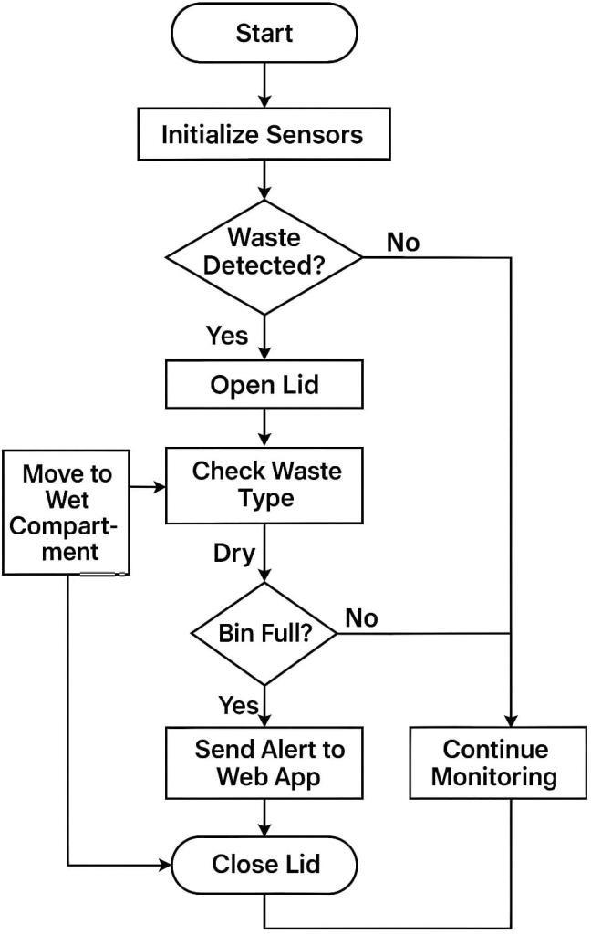

Fig 3.1 Architecture of System

The following figure illustrates the sequential workflow of a Smart Waste Bin System that can detect waste, classify it, sort it according to respective containers, and detect its own capacity by real-time communication and surveillance. I am going to detail the entire flow step by step so that working will be evident.

We start from the Start node, where the smart bin system is switched on. This can occur when the bin is first powered on, reset, or goes online when the Ultra Sonic Sensor senses an object. Once the system has been initialized, the first thing it does is initialize its sensors. This configuration process is important because the sensors are the system's central intelligence — without them, the bin would have no way of perceiving its environment or interacting with waste input in any useful manner.
Once successfully initialized, the system enters an active surveillance mode in which it remains alert, waiting for any sign of incoming trash. It does so with an array of sensors — possibly from proximity sensors to detect movement, infrared or ultrasonic sensors to sense an object, and perhaps even image systems in upscale models. The system is thus posed with its first choice point: "Waste Detected?"

If no waste is detected at this stage, the intelligent bin just remains in passive monitoring mode, conserving energy and system resources. If waste is detected, however, the system acts accordingly by proceeding to open the lid. The opening of this lid is automatic, touchless, and aimed at enhancing cleanliness through the reduction of direct physical contact between users and the bin.

Once the lid is opened, the system assumes a more sophisticated role: identifying the type of waste being thrown away. The system must determine whether the waste material is wet — such as food waste, liquid products, and biodegradable waste — or dry — such as paper, plastic wraps, cardboard, or metal products. The identification can be performed through various mechanisms such as moisture detecting sensors, computer vision algorithms, or chemical analyzing tools embedded in the bin.
Once correct identification of the waste type is made, the smart bin will automatically sort the waste into the relevant compartment.
If the waste is wet, the system places the waste into the wet compartment of the bin. When the waste is dry, it directs the material into the dry compartment.

This automatic sorting based on sources is one of the key innovations of the system. Sorting wet and dry waste at the point of disposal, the system greatly eases subsequent recycling processes, reduces contamination of recyclables, and encourages better waste management overall.

On sorting, the system does not just shut down. Instead, it performs one additional critical test: it checks whether the bin is full. This is a critical maintenance and operational procedure whereby waste spillover is prevented and whereby the system continues to operate without creating a hygiene issue to the surrounding area.

At this decision point if the bin is not full, the system reverts back to its monitoring state, holding on to more waste and repeating the process again when required.
However, if the bin is full, the smart bin system triggers a real-time notification to a connected web application. The notification serves as a hint to the concerned waste management staff, building maintenance team, or municipal workers that the bin
should be emptied. The notification can include useful information such as the bin location, the bin content, and even the urgency level needed.

Finally, after the necessary warnings have been issued, the system closes the lid. This last step maintains the cleanliness of the waste inside the bin, prevents odor leakage, and keeps pests or insects from entering the waste.

In brief, the image provides a clear and structured image of how the smart bin system functions. It shows a complete cycle from waste detection to classifying it, sorting it correctly, monitoring its own capacity, and actively communicating with human operators when assistance is needed.

The entire process highlights the intelligence, efficacy, and functionality of the smart bin in ensuring sustainability programs. Such a system can be particularly beneficial in modern smart cities, shopping centers, airports, hospitals, corporate complexes, and residential societies. Not only does it ease the burden of manual cleaning staff, but it also facilitates cleaner environments, enhanced recycling percentages, and smarter utilization of resources.

Overall, the smart dustbin is a small but significant pointer to how automation and IoT (Internet of Things) technologies can revolutionize even the most basic human processes, like rubbish disposal, to create a brighter and cleaner tomorrow.

Modules:

All the functionality in our Smart Waste Management System has been segmented into a number of significant modules. Each module takes care of a particular responsibility and works together towards developing an efficient, responsive, and smart waste management solution.

    - Sensor Initialization and Monitoring Module:

This module is the point of origin for the system. The moment the smart bin is turned on, the Sensor Initialization module starts working. It makes sure that all necessary sensors — object detection and level measurement ultrasonic sensors, and waste type identifying soil moisture sensor — are initialized and calibrated. The module continuously maintains the sensors in a low-power monitoring mode, making sure the bin is at any moment ready to detect objects nearby or determine waste levels. Timely
sensor initialization is important since delay or mistake in this regard will impact the entire operation of the bin.

Responsibilities:
        - Initialize all sensors with power and settings.
        - Continuously monitor the environment.
        - Automatically detect waste.

    - Waste Detection and Classification Module:

If the monitoring module identifies an object near the bin (with the help of ultrasonic sensing), the Waste Detection and Classification Module is activated. It automatically opens the bin lid using a servo motor, with no direct physical contact involved in depositing the waste inside. Once the lid is open and the waste is placed inside, this module employs the soil moisture sensor to identify the type of waste. Using pre-specified moisture levels, the system will label the waste as wet (organic, biodegradable waste) or dry (paper, plastic, or metal).

Responsibilities:
        - Detect incoming waste/object.
        - Categorize the waste as wet or dry depending on moisture levels.
        - Prepare the waste for the sorting action.

    - Automatic Lid Operation Module:

This module is specifically concerned with the smart opening and closing of the bin lid. Upon a user's approach, the ultrasonic sensor input causes the lid to open automatically. Once waste has been sorted and categorized, and no other movement is found near the bin, the lid automatically closes. This operation is controlled through operating a servo motor that is linked to the lid. Automatic lid closure not only ensures a hygienic touchless interaction but also saves energy and keeps the bin tidy.

Responsibilities:
        - Open the bin lid upon detection of waste.
        - Close the lid automatically once waste disposal and classification are done.
        - Enhance hygiene and user experience.

    - Waste Sorting and Compartment Control Module:

Once the waste is classified, this module makes sure that it is routed into the proper compartment in the bin — wet or dry. The smart bin has two distinct compartments to avoid mixing of various types of waste. This module is used to mechanically move (tilting mechanisms, rotary guides, or a simple flap operated by servo motors) the waste to the correct section. This guarantees that waste is sorted at the point of origin itself, so recycling and processing waste in the future will be much easier and much more efficient.

Responsibilities:
        - Shift or tilt the waste into the proper compartment according to classification.
        - Avoid cross-contamination between wet and dry waste.
        - Enhance waste recycling efficiency.

    - Fill Level Monitoring and Alert System Module:

This module is very important to make sure the bin does not overfill. It employs ultrasonic sensors that are installed within each compartment to check the fill levels at all times. The system is programmed to identify when a compartment is almost full — for instance, when there are only 10% of empty space left. Once a critical fill level is detected, this module sends out an alert. It reports the status of the bin to a cloud server or web application, allowing real-time monitoring by waste collection teams. The real- time alerting system optimizes waste collection schedules, conserving labor, fuel, and time.

Responsibilities:
        - Monitor the level of waste within wet and dry compartments independently.
        - Send alerts when bins are full.
        - Facilitate proactive waste collection and avoid overflow conditions.
    - Web Application and Cloud Integration Module:

This module makes sure that the smart bin is not cut off, rather remains in contact with external monitoring systems. The ESP-01 Wi-Fi module is utilized to forward data gathered from the sensors to a cloud-based platform (such as ThingSpeak) or a custom- made web application created using Flask, HTML, and CSS. The web dashboard offers a graphical interface for administrators or garbage collectors to view the bin's status, fill levels, and whether an emergency pickup is required. This module also maintains historical data for analysis — assisting authorities in comprehending usage patterns and further optimizing their resources.

Responsibilities:
        - Stream bin data to the cloud in real-time.
        - Represent bin status graphically on an easy-to-use dashboard.
        - Help route pickups for optimal routes using live bin status.
        - Store historical information for planning waste management.

Algorithms:

The Smart Waste Management System operates on a couple of straightforward but significant algorithms to provide its functionality:

    - Algorithm 1: Waste Detection and Lid Control
      - Boot the system and set all sensors.
      - Permanently check for any object coming near the bin using the ultrasonic sensor.
      - If an object is sensed:
        - Open the lid through the servo motor.
      - If no object is sensed:
        - Maintain the lid closed and keep monitoring.

    - Algorithm 2: Waste Type Classification and Sorting
      - Once the lid opens and waste is sensed, detect the type of waste using the soil moisture sensor.
      - If the sensor senses excess moisture:
        - Tag the waste as wet waste.
        - Direct the waste into the wet compartment through servo control.
      - Otherwise:
        - Tag it as dry waste.
        - Direct the waste into the dry compartment.

    - Algorithm 3: Bin Fill Level Monitoring and Notification:
      - Monitor the fill levels of both compartments continuously through ultrasonic sensors within the bins.
      - When either the wet or dry compartment is at the set maximum fill level:
        - Trigger an alarm.
        - Report bin status (location and fill percentage) to the web application through the ESP-01 Wi-Fi module.
      - Display real-time bin status on the web dashboard.

IMPLEMENTATION

Hardware Components:

The hardware implementation for the Smart Waste Management System involves:

    - Arduino uno board:

The Arduino UNO is an open-source microcontroller board based on the ATmega328P microchip. It is one of the most popular and beginner-friendly boards in the Arduino family, widely used in electronics projects and prototyping. The board offers a balanced mix of power, simplicity, and flexibility, making it ideal for both novice and experienced developers.

General Features:
        - Serves as a reliable platform for controlling sensors, actuators, and other hardware components.
        - Operates at 5V and includes onboard voltage regulation to power connected peripherals.
        - Features a USB-to-serial interface for easy programming and serial communication.
        - Equipped with 14 digital I/O pins (6 with PWM output) and 6 analog input pins for versatile interfacing.
        - Includes a reset button and power LED indicators for better development control.
        - Supports programming via the Arduino IDE with a wide range of libraries and community support
      - Specifications:

Feature | Specification
Microcontroller | ATmega328P
Operating voltage | 5V
Recommended input voltage | 7–12V
Digital I/O pins | 14 (6 support PWM output)
Analog input pins | 6
Flash memory | 32 KB (0.5 KB used by bootloader)
SRAM | 2 KB
EEPROM | 1 KB
Clock speed | 16 MHz
USB interface | Used for programming and serial  communication
Power jack | Supports external power supply
ICSP header | Supports in-system programming

Table 4.1 Arduino Uno Specifications

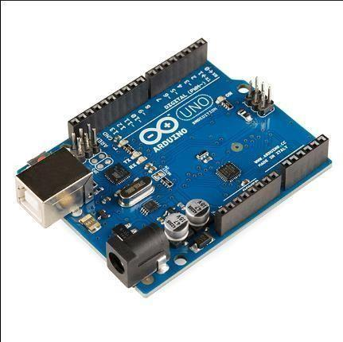
Fig 4.1 Arduino Uno
    - Ultrasonic Sensor (HC-SR04) - Detects Waste Level Inside the Bin:

General Features:
- Measures distance using ultrasonic waves.
- Can accurately determine the waste level inside the bin by calculating the distance to the surface of the waste.
- Operates in a wide range of applications including waste management, robotics, and automation.
- Provides a non-contact measurement method, making it suitable for waste level detection in bins.

      - Specifications:

Feature | Specification
Operating Voltage | 5V
Range | 2 cm to 400 cm
Accuracy | ±3 mm
Trigger Input Pulse Width | 10 µs
Echo Output Pulse Width | Corresponds to distance
Power Consumption | 15 mA (typical)
Interface | Digital I/O (Trigger and Echo)
Dimensions | 45 mm x 20 mm x 15 mm
Table 4.2 Ultra Sonic Sensor Specifications

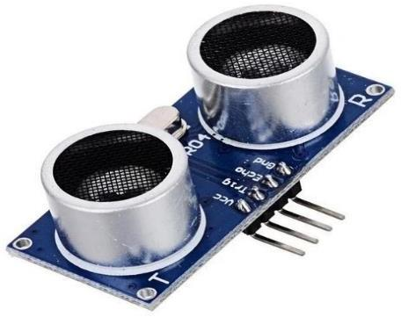
Fig 4.2 Ultra Sonic Sensor
    - Soil Moisture Sensor - Differentiates Between Dry and Wet Waste:

General Features:
- Measures the water content in the waste (or soil).
- Helps differentiate between dry and wet waste by detecting moisture levels.
- Used in agriculture, gardening, and waste management systems.
- Easy to interface with microcontrollers like Arduino for real-time data acquisition.

      - Specifications:

Feature | Specification
Operating Voltage | 3.3V - 5V
Measurement Range | 0 to 100% (Relative Moisture)
Output Type | Analog (voltage)
Power Consumption | Low (<10 mA)
Sensitivity | Adjustable via potentiometer
Dimensions | 60 mm x 20 mm

Table 4.3 Soil Moisture Sensor Specifications
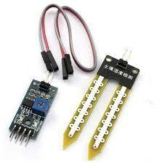
Fig 4.3 Soil Moisture Sensor
    - Servo Motor:

General Features:
- Provides precise control over angular position.
- Commonly used in robotics, automation, and control systems.
- Can be used to open or close a dustbin lid automatically when a user is detected.
- Operates under different voltage and current ratings, making it adaptable for various applications.

      - Specifications:

Feature | Specification
Operating Voltage | 4.8V - 6V
Torque | 1.5 - 3 kg.cm
Rotation Range | 0° to 180°
Control Signal | PWM (Pulse Width Modulation)
Power Consumption | 10 - 20 mA (no load)
Dimensions | 40 mm x 20 mm x 40 mm

Table 4.4 Servo Motor Specifications
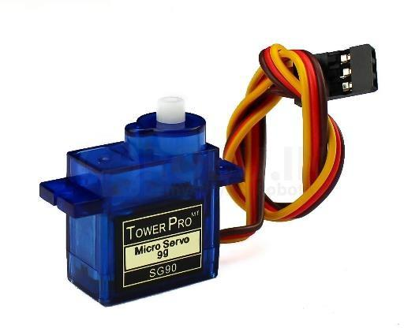
Fig 4.4 Servo Motor
    - ESP-01 Wi-Fi Module - Sends Real-Time Bin Status to the Cloud (ThingSpeak):

General Features:
- Provides wireless connectivity for IoT (Internet of Things) applications.
- Allows communication between the microcontroller (e.g., Arduino) and cloud services like ThingSpeak.
- Small form factor and low power consumption make it ideal for battery-powered projects.
- Supports a variety of network protocols including TCP/IP and HTTP for data transfer.

      - Specifications:

Feature | Specification
Operating Voltage | 3.3V
Wi-Fi Standards | IEEE 802.11 b/g/n
Maximum Data Rate | 72.2 Mbps
Transmission Range | 100 m (indoor)
Flash Memory | 1 MB
Power Consumption | 130 mA (when active)
Dimensions | 24.8 mm x 14.3 mm x 3.2 mm

Table 4.5 WIFI Module Specifications
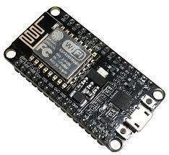
Fig 4.5 Wi-Fi Module
    - Power Supply Unit - Provides Stable Voltage for All Components:

General Features:
- Supplies the necessary power for all connected components in the circuit.
- Ensures stable voltage levels for components like sensors, motors, and modules.
- Can be configured to provide different voltage outputs (e.g., 5V, 12V).

      - Specifications:

Feature | Specification
Input Voltage | 110V - 240V AC
Output Voltage | 5V DC (for low-voltage devices)
Output Current | 1A or higher depending on components
Efficiency | 80% or higher
Protection Features | Overload, short circuit, over voltage
Dimensions | Varies (depends on model)
Table 4.6 Power Supply Specifications
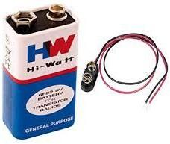
Fig 4.6 Power Supply
    - Breadboard and Jumper Wires - Connects the Circuit Components:

General Features:

- Breadboard: A tool for prototyping electronic circuits without soldering.
- Jumper Wires: Flexible wires used to make connections between different components on the breadboard.
- Essential for assembling and testing circuits before moving to a permanent setup.

      - Specifications:

Feature | Specification
Breadboard Size | Standard (830 tie-points)
Jumper Wire Length | 10 cm to 30 cm
Wire Gauge | 22 AWG (standard)
Compatibility | Fits most standard breadboards
Material | PVC (for wires), plastic (for breadboard)
Table 4.7 Breadboard and Jumper Wires Specifications

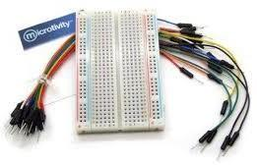

Fig 4.7 7 Breadboard and Jumper Wires

Software:

Arduino IDE:

Arduino Integrated Development Environment or IDE is a PC application that is used to develop, compile, and upload Arduino board codes. It supports programming in C and C++ and is user-friendly and accessible both to beginners and professionals. The Arduino IDE has been used here to develop and upload the program controlling the sensor, servo motor, and the communication modules. It also provides inbuilt libraries and serial monitor support, which help with debugging and seeing real-time hardware information.

ThingSpeak:

ThingSpeak is an open-source IoT cloud platform that enables users to store, analyze, and visualize data from devices, collect data, and provide real-time data feeds and also integrate directly with MATLAB for sophisticated analytics.
ThingSpeak is used in this project here to record the waste level information gathered from the bins and remote monitoring can be accomplished. ESP-01 Wi-Fi board sends the reading of the sensors to ThingSpeak where one can visualize the data in the form of graphs and an alert can be set if the bin is full.

HTML, CSS, Flask:

HTML (Hypertexts Markup Language) and CSS (Cascading Style Sheets) are employed for designing and styling the web dashboard to show the status of the bins. The backend server to fetch data from ThingSpeak and dynamically update the dashboard is implemented using Flask, which is a light-weight Python web framework. This combination enables the user to view at their fingertips a visually engaging and responsive web interface through which they can see in real-time from any internet-enabled device the bin fill levels.

Arduino Code:
#include <Servo.h>
// Pin Definitions #define trigMain 5
#define echoMain 6
#define trigWetBin 8
#define echoWetBin 9
#define trigDryBin 10
#define echoDryBin 11 #define moisturePin A0

#define servoLidPin 4
#define servoSegregatePin 3

Servo servoLid;
Servo servoSegregate;

// Parameters
int delayPerStep = 10; int lidClosedAngle = 90; int lidOpenAngle = 120;
int segregationWet = 130; int segregationDry = 50; int wetThreshold = 500; int detectionDistance = 30;
int binFullThreshold = 15; // <=15cm = FULL

void setup() { Serial.begin(9600);
pinMode(trigMain, OUTPUT); pinMode(echoMain, INPUT); pinMode(trigWetBin, OUTPUT); pinMode(echoWetBin, INPUT); pinMode(trigDryBin, OUTPUT); pinMode(echoDryBin, INPUT);

servoLid.attach(servoLidPin); servoSegregate.attach(servoSegregatePin);

servoLid.write(lidClosedAngle); servoSegregate.write(90);

Serial.println("Smart Dustbin System Initialized");
}

void loop() {
// Always check bin levels
long wetDistance = readUltrasonic(trigWetBin, echoWetBin); long dryDistance = readUltrasonic(trigDryBin, echoDryBin);
String wetStatus = (wetDistance > 0 && wetDistance <= binFullThreshold) ? "FULL" : "NOT_FULL";
String dryStatus = (dryDistance > 0 && dryDistance <= binFullThreshold) ? "FULL" : "NOT_FULL";

Serial.print("levelWet="); Serial.print(wetDistance); Serial.print("&"); Serial.print("levelDry="); Serial.print(dryDistance); Serial.print("&"); Serial.print("fillWet="); Serial.print((wetStatus == "FULL") ? 100 : 0); Serial.print("&");
Serial.print("fillDry="); Serial.print((dryStatus == "FULL") ? 100 : 0); Serial.print("&");

// Main object detection
long mainDistance = readUltrasonic(trigMain, echoMain); Serial.print("mainDistance="); Serial.print(mainDistance); Serial.print("&");

if (mainDistance > 0 && mainDistance < detectionDistance) { Serial.println("objectDetected=1");

smoothMove(servoLid, lidOpenAngle);

int moistureValue = analogRead(moisturePin); Serial.print("moisture="); Serial.print(moistureValue); Serial.print("&");

String type; int angle;

if (moistureValue >= wetThreshold) { type = "DRY";
angle = segregationDry;
} else {
type = "WET";
angle = segregationWet;
}

Serial.print("type="); Serial.print(type); Serial.print("&"); Serial.print("angle="); Serial.println(angle);

smoothMove(servoSegregate, angle);
} else { Serial.println("objectDetected=0");

smoothMove(servoLid, lidClosedAngle); smoothMove(servoSegregate, 90); Serial.print("type=NONE&angle=90\n");
}
delay(400);
}

void smoothMove(Servo &servo, int targetAngle) { int current = servo.read();
if (current < targetAngle) {
for (int i = current; i <= targetAngle; i++) { servo.write(i);
delay(delayPerStep);
}
} else {
for (int i = current; i >= targetAngle; i--) { servo.write(i);
delay(delayPerStep);
}
}
}

long readUltrasonic(int trigPin, int echoPin) { digitalWrite(trigPin, LOW); delayMicroseconds(2); digitalWrite(trigPin, HIGH); delayMicroseconds(10); digitalWrite(trigPin, LOW);
long duration = pulseIn(echoPin, HIGH, 30000); if (duration == 0) return -1;
return duration * 0.034 / 2;
}

Web Application Codes:

    - CSS Code:
/* General Styles */
body {
font-family: Arial, sans-serif; margin: 0;
padding: 0;
box-sizing: border-box;
}

header {
background-color: #4CAF50; color: white;
padding: 1rem; text-align: center;
}

header h1 { margin: 0;
font-size: 2.5rem;
}

header p {
margin: 0.5rem 0; font-size: 1.2rem;
}
nav ul {
list-style: none; padding: 0; display: flex;
justify-content: center; gap: 1rem;
}

nav ul li { display: inline;
}

nav ul li a { color: white;
text-decoration: none; font-weight: bold;
}

section { padding: 2rem; margin: 1rem;
}

h2 {
border-bottom: 2px solid #4CAF50; padding-bottom: 0.5rem;
}

ul {
list-style: disc; padding-left: 2rem;
}

footer {
background-color: #4CAF50; color: white;
text-align: center; padding: 1rem; margin-top: 2rem;

- RESULT:
  - Result:
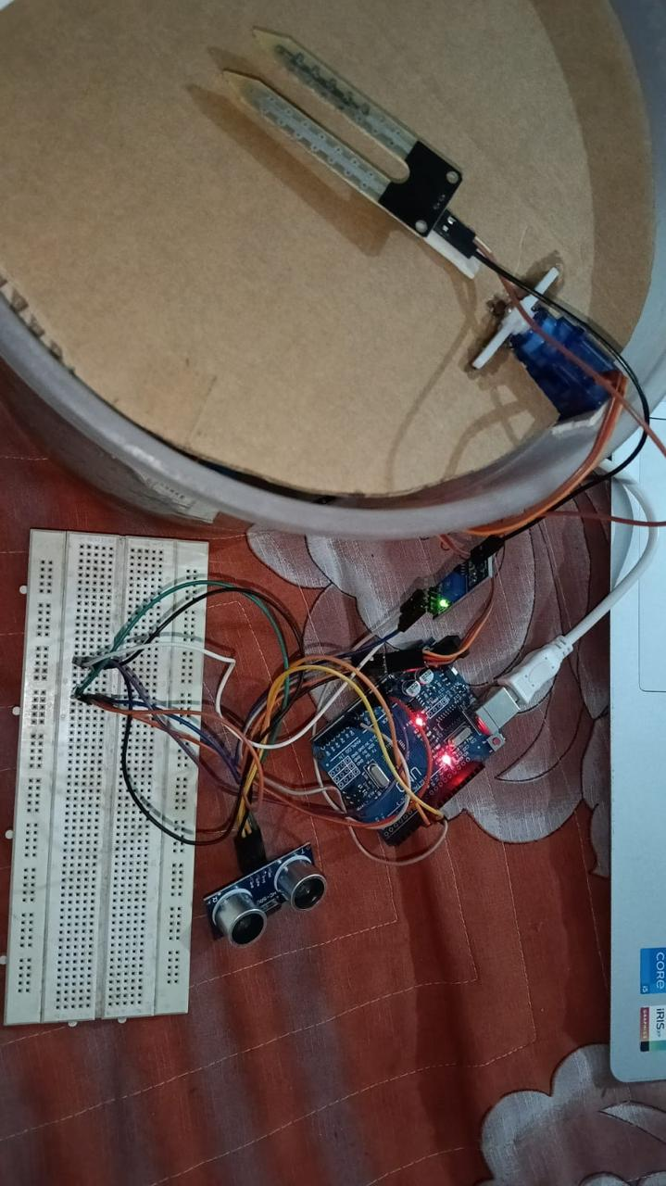
Arduino uno
Breadboard
Ultrasonic sensor
Servo motor
Soil moisture sensor
Smart Waste Management Dustbin
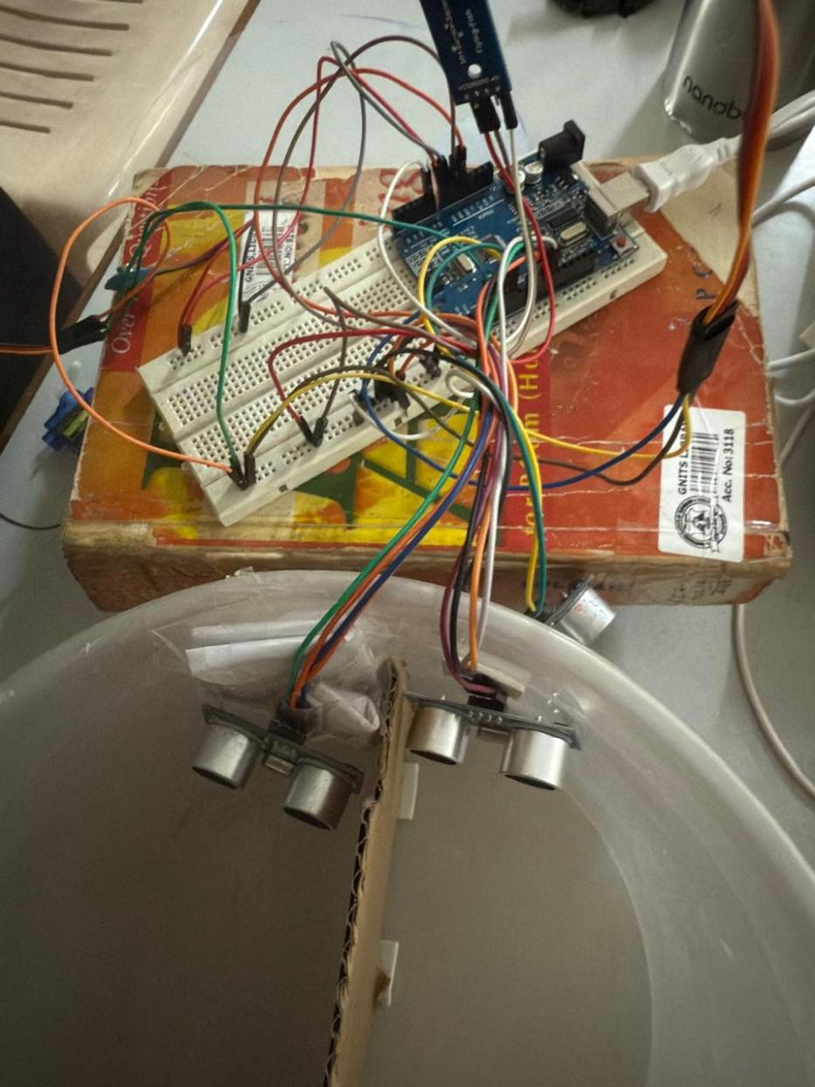
US1 : Dry waste level
US2 : Wet waste level
Segregation of wet & dry waste compartments

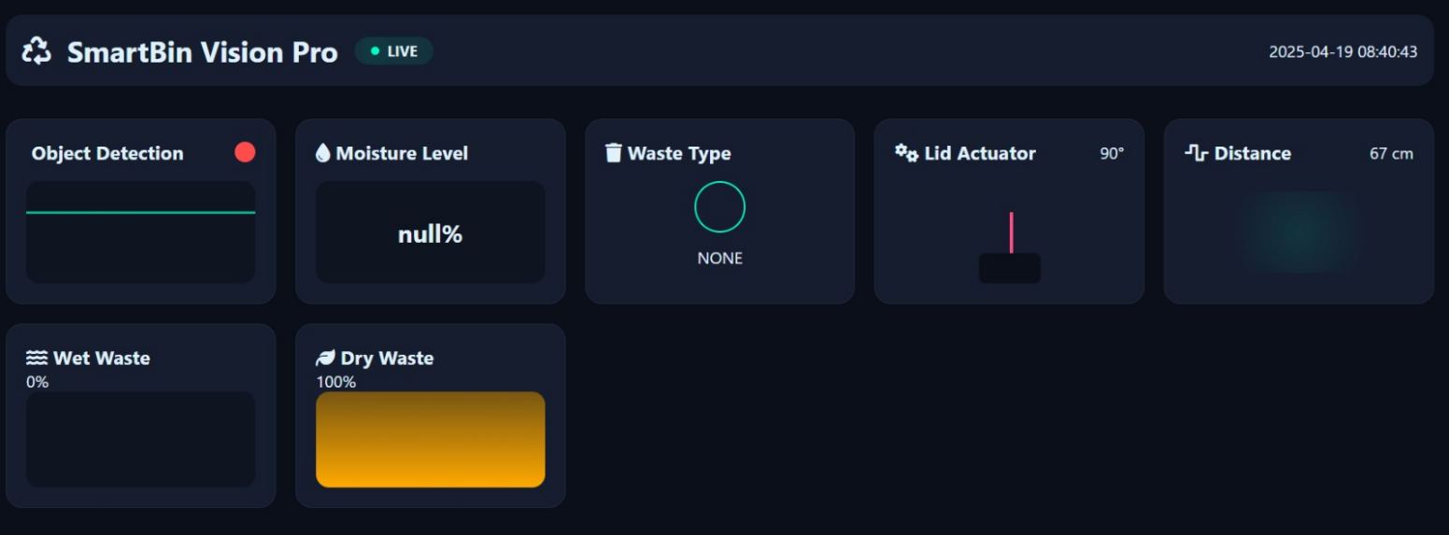
Web Application Dashboard

Fig 5.1 Results

Performance Metrics:

Parameter | Result
Waste level detection accuracy | ~95%
Wet/Dry waste classification accuracy | ~90%
Cloud update time | 5–7 seconds
Energy consumption | Optimized using sleep modes

Table 5.1 Performance Metrics

Limitations:

Power Dependency:
The system relies on a battery or external power source. In remote areas, this might be impractical unless solar power is implemented.

Sensor Reliability:
Ultrasonic and moisture sensors can give inaccurate readings due to environmental conditions (e.g., wet dustbins, sensor misalignment, obstructed surfaces).

Moisture Detection Ambiguity:
Moisture level alone might not always accurately classify waste as wet or dry (e.g., a wet plastic wrapper).

Usability:
Each bin is different from what our prototype is. Trying to a city-wide
level requires more infrastructure for managing hundreds of bins.

CONCLUSION AND FUTURE ENHANCEMENTS

Conclusion:
- This project is a modest contribution to the overarching goal of effective waste management, a topic that remains relevant. By putting together, the many ingredients we used such as: Arduino UNO, ultrasonic sensors, soil moisture sensors, servo motors, ESP-01 Wi- Fi modules, we were able to combine elements to create an intelligent dustbin system with waste identification through automating waste management, as well as real-time cloud status monitoring. With the use of Arduino IDE, ThingSpeak and a little web dashboard build using HTML, CSS, and Flask, we supplied the food to our exotic hardware-software dish.

- Throughout this project we faced numerous struggles such as calibrating sensor contact points and maintaining Wi-Fi signal strength, subsequently realizing these struggles have helped make our systems more solid and scalable than we could have imagined. Of everything, seeing the autonomous bin refreshing the dashboard in real time was the greatest thrill of the project. It gave credence to value IoT bring to the simplification of our daily endeavors and innovation towards developing smarter, sustainable solutions.

- The intent of the project demonstrates the applicability of even low-cost technologies. These bins can be implemented in homes, offices and public spaces to provide a cleaner public sanitation landscape, improve waste management systems and help even gather metrics when optimizing waste collection routes throughout cities.

- Imagine a world where the trash bins themselves are able to collect material more effectively without needing to be cognizant of their waste collection - this is the direction new innovations such as this can lead us.

- Overall, this project helped us combine creativity, technicality and problem-solving skill to produce something tangible, and it left us feeling encouraged to pursue further avenues on how technology can enhance our environments further. As much as there is always room for improvement - including solar powered units, machine learning waste classification, or phone alerts - this project has provided a useful starting point for larger and wiser waste collection in the future.

Future Enhancements:
Our current smart waste management system operates great, however, there is a huge opportunity to make it even smarter, more efficient, and more sustainable for the environment. Here is a high-level view of how we envision its future:

    - Solar Power Integration:

One of the first upgrade changes we want to achieve is a solar panel powered smart waste management system. Doing this will allow the smart bins to operate without dependence on an external power source making them suitable for any outdoor environment such as parks, public streets, or rural settings. Using solar power helps reduce operational costs, and the project would align with sustainable, environmentally friendly practices.

    - AI-Based Waste Classification:

Gen 1 bins can distinguish between dry/wet waste, but with the addition of a camera module and a machine learning model trained to classify different types of waste (e.g. a plastic, a paper, an organic waste), we can do so much more. This upgrade allows us to automate the classification process, increase the recycling rate, separate waste contamination and classify waste which makes them smarter and more autonomous.

    - Mobile Application for Notifications:

To facilitate monitoring, a dedicated mobile app can be created and all users and waste collectors can get notified in real time to indicate when a bin is full, for maintenance or if there is a system fault. This feature helps with operational response time, timely notification for waste disposal that eliminates overfilled bins/unsanitary conditions.

    - Smart Route Optimization for Waste Collection:

By networking up to multiple bins, and analyzing their fill states, we could introduce dynamic route planning from waste collection vehicles. In this case, the design would approach every bin based on its fill state. Rather than having a fixed schedule, the vehicle only transitions to the bins that are almost full. This would save time, fuel, and labor—all of which contribute towards a smarter, greener and more efficient waste management ecosystem at the city level.
    - Rugged and Weatherproof Design:

For this to work outdoors, the system needs to be tough. Future designs should focus on constructing a weather-resistant enclosure that protects the electronics and sensors from the rain, dust, temperatures, and brutal impact damage. If industrial-grade materials were used to fabricate the enclosures, we could greatly enhance durability and lifespan.

    - Accessibility Features:

We could also make the bin system more inclusive by adding audio prompts or LED signals to help guide users, especially those who are visually impaired or elderly. In this way, the smart bin would be more accessible and community-friendly. Examples include a voice message saying Bin ready, or an LED that changed color in response to the bin fills state.

    - Expansion to Multi-bin Sorting Systems:

In the long term, the project could morph into a multi-bin system, where waste is automatically sorted into compartments (organic, plastic, metals) directly from the point of disposal. This would vastly increase recycling and reduce the burden on waste processing facilities.

REFERENCES

- Arduino Uno Datasheet.
- HC-SR04 Ultrasonic Sensor Manual.
- ThingSpeak IoT Cloud Documentation.
- Research on Smart Waste Bins using IoT – IJERT, 2023.
- Smart Waste Monitoring Systems – IEEE Xplore, 2022.

